**Name: Ahmad Tariq**

**Roll no: 22I-1534**

**BS(SE) - C**

NUCES Airline Flight System (NAFS)

REPORT

This is a Flight Management System built/coded solely for academic purpose. It manages flight schedules, bookings, payments and also requires password authentication which is essential for any Management System to function properly. It uses concepts of Object Oriented Programming to a good extent, which are the bread and butter of programmers today.

This Management System comprises of 14 classes, which are listed as follows:

* User Class
* Admin Class (parent: User)
* Passenger Class (parent: User)
* Airplane Class
* Airport Class
* City Class
* Country Class
* Distance Class
* Flight Class
* Flight Time Class
* Clock Class
* Bank Account Class
* Passport Class
* Menu Class

This code also has one header file, namely ‘side functions’.

**Explanation of OOP concepts used:**

1. **Inheritance:**

There are two instances of inheritance in this code:

* User(parent) – Admin(child):

An admin can be classified as a user, as it has common properties (data members & functions) with other end users of NAFS.

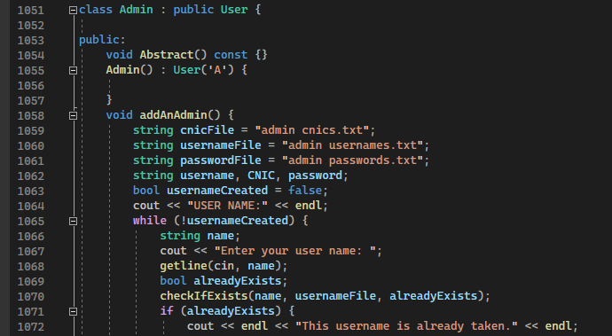

* User(parent) – Passenger(child):

A passenger can be classified as a user, as it has common properties (data members & functions) with other end users of NAFS.

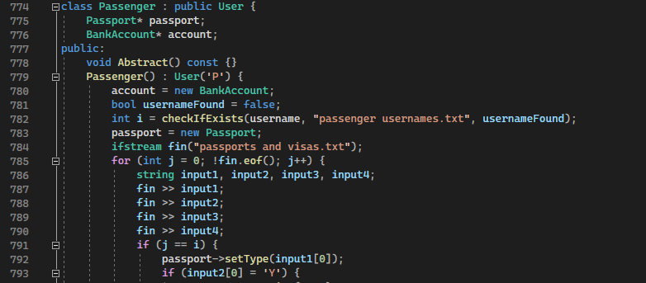

1. **Composition**:

* Country (whole) – City (part):

A Country is incomplete without Cities and Cities cannot exist outside of Country.

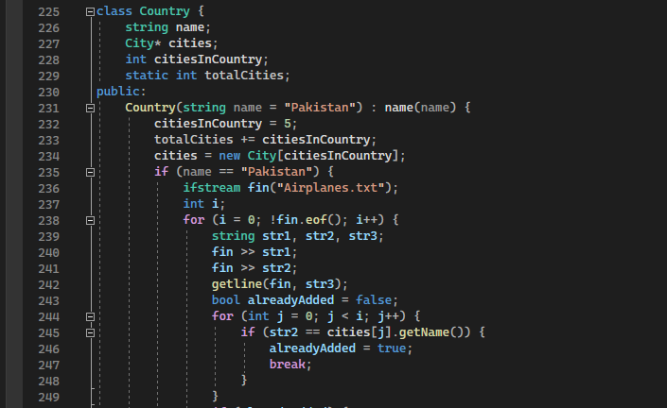

* City (whole) – Airport (part):

A City is incomplete without an Airport and Airports cannot exist outside of City.

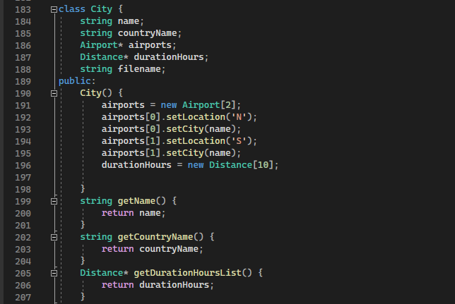

* Flight (whole) – Flight time (part):

A flight is incomplete without Flight Time (Departure & Arrival) and Flight Time cannot exist outside of Flight.

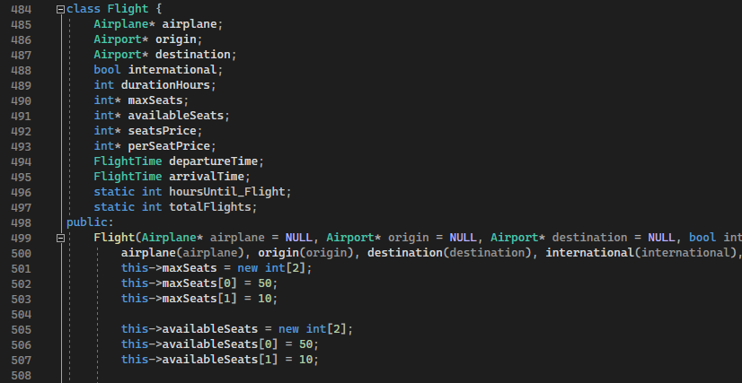

1. **Aggregation**:

* Airport (whole) – Airplane (part):

An airport consists of Airplanes but is not incomplete without them, and Airplanes can exist outside of Airports.

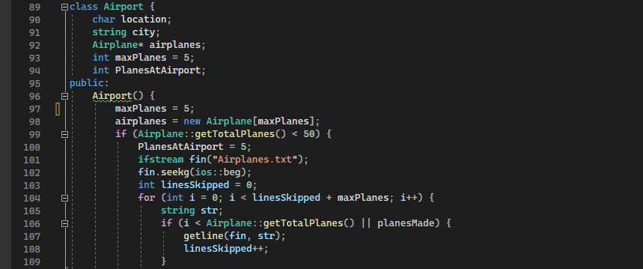

1. **Association**:

* Flight (whole) – Airport (part):

A flight consists of Airports (Origin & Destination) but Airports can exist outside of Flight.



* Passenger – Bank Account:

A Passenger has a Bank Account and but they do not consist of Bank Accounts.

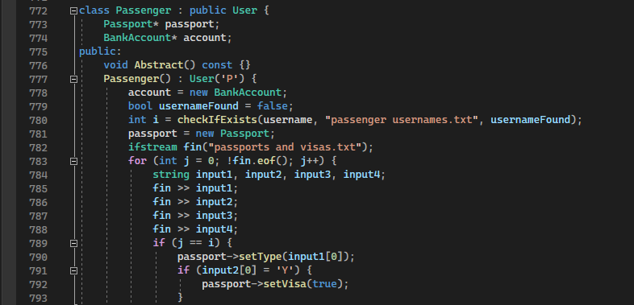

* Passenger – Passport:

A Passenger has a Passport and but they do not consist of Passports.



* Flight – Airplane:

A flight has an Airplane but they do not consist of Airplanes.



* City - Distance:

Cities use Distances and City doesn’t consist of Distance.



UML Diagrams:

**Left Page:** Right page: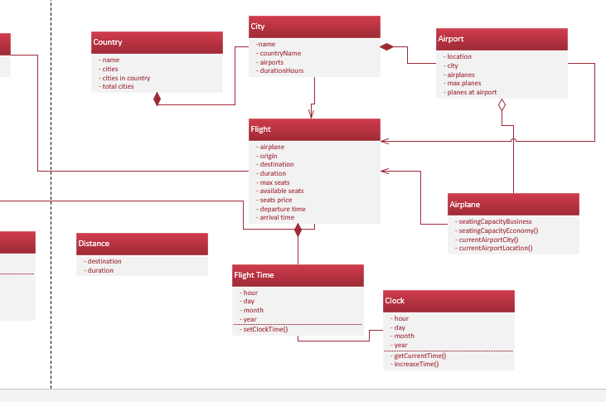

**Right page:**

